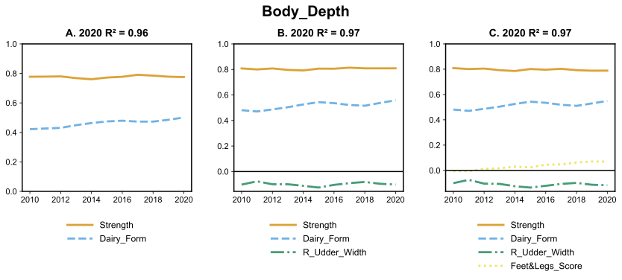Figure S1: Coefficients of 2 (A), 3 (B) and 4(C) factor regression on Body Depth over time with corresponding R² based on year 2020.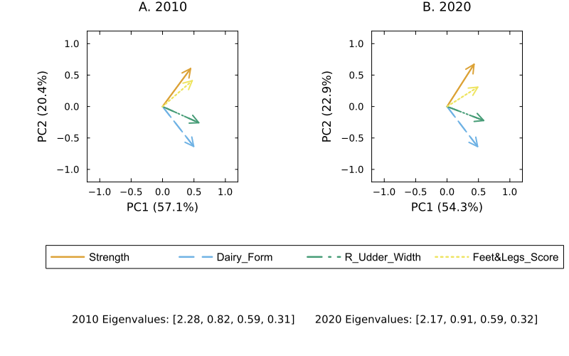Figure S2. Principal component analysis biplots for the 4-factor regression for Body Depth in 2010 and 2020.
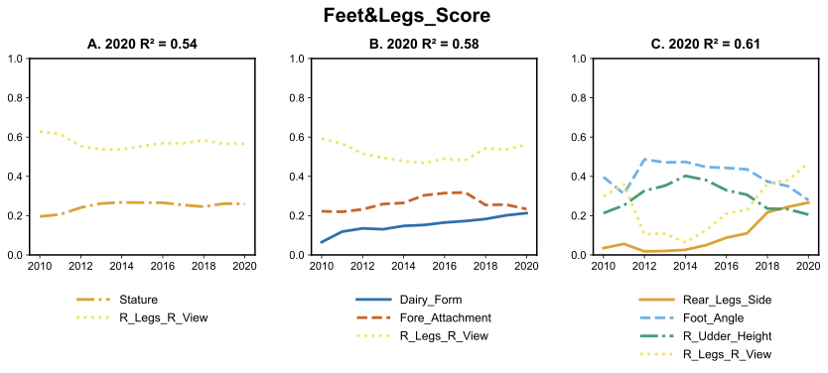Figure 3a: Coefficients of 2 (A), 3 (B) and 4(C) factor regression on Foot and Legs Score over time with corresponding R² based on year 2020.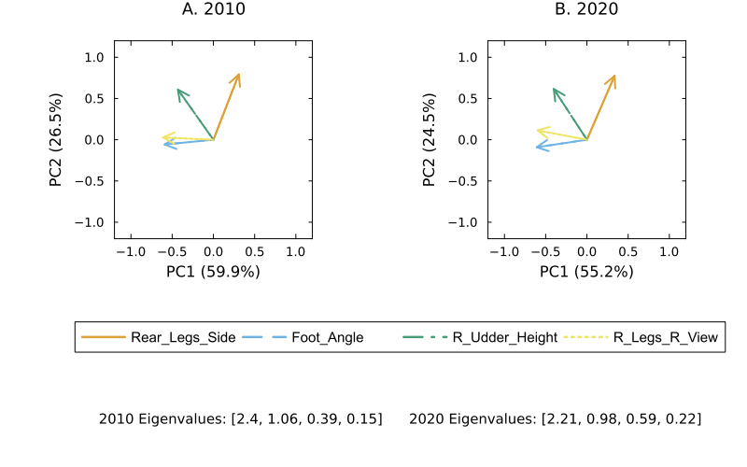Figure 4a. Principal component analysis biplots for the 4-factor regression for Foot and Legs Score in 2010 and 2020.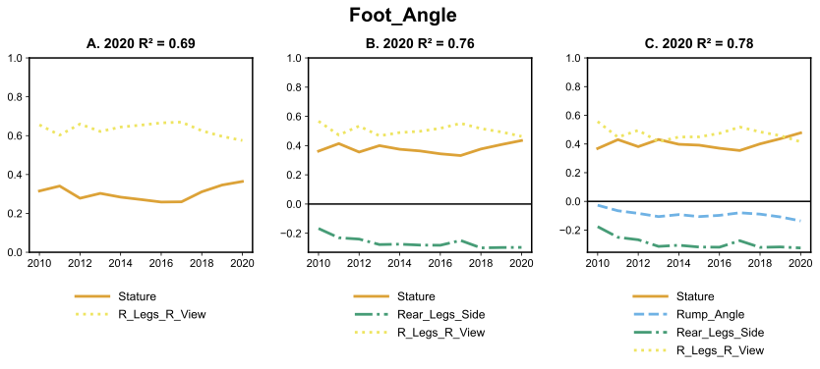Figure 5a: Coefficients of 2 (A), 3 (B) and 4(C) factor regression on Foot Angle over time with corresponding R² based on year 2020.
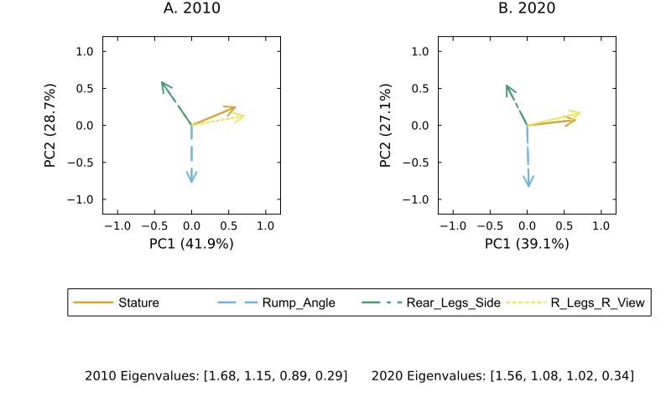Figure 6a. Principal component analysis biplots for the 4-factor regression for Foot Angle in 2010 and 2020.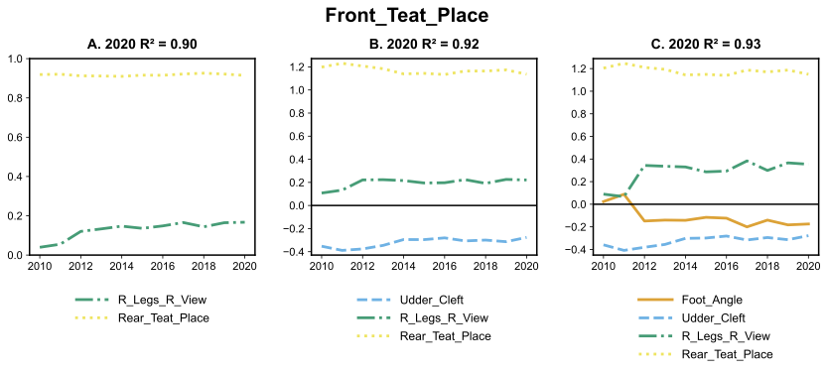Figure 7a: Coefficients of 2 (A), 3 (B) and 4(C) factor regression on Front Teat Placement over time with corresponding R² based on year 2020.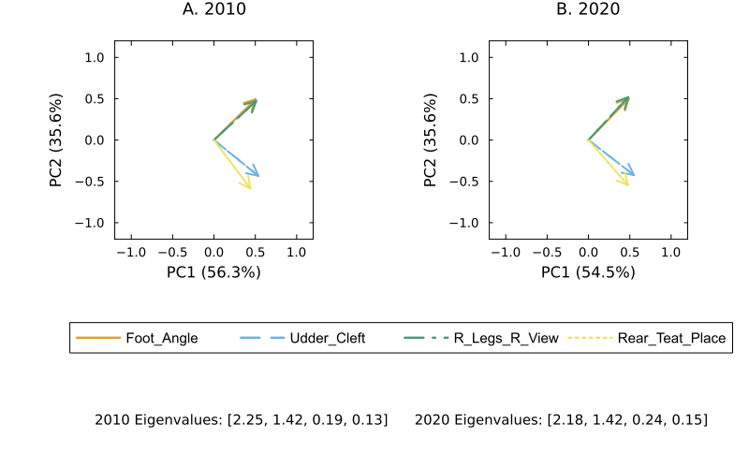Figure 8a. Principal component analysis biplots for the 4-factor regression for Front Teat Placement in 2010 and 2020.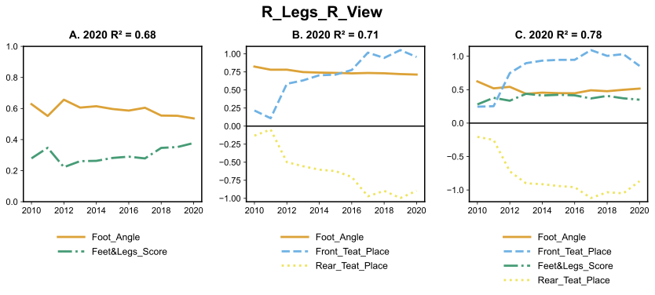Figure 9a: Coefficients of 2 (A), 3 (B) and 4(C) factor regression on Rear Legs Rear View over time with corresponding R² based on year 2020.
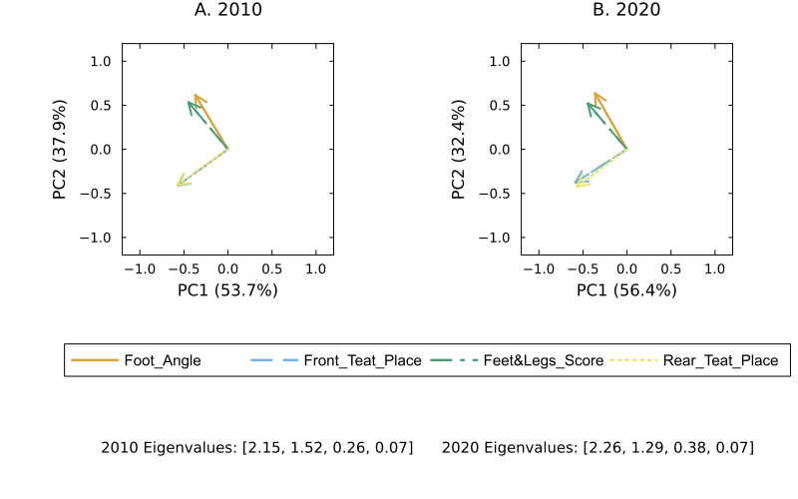Figure 10a. Principal component analysis biplots for the 4-factor regression for Rear Legs Rear View in 2010 and 2020.
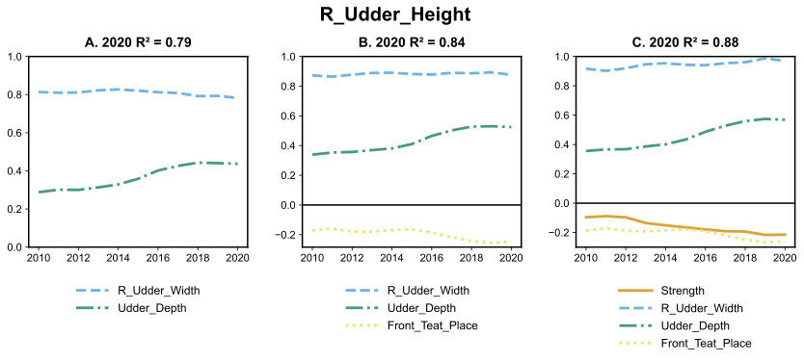Figure 11a: Coefficients of 2 (A), 3 (B) and 4(C) factor regression on Rear Udder Height over time with corresponding R² based on year 2020.
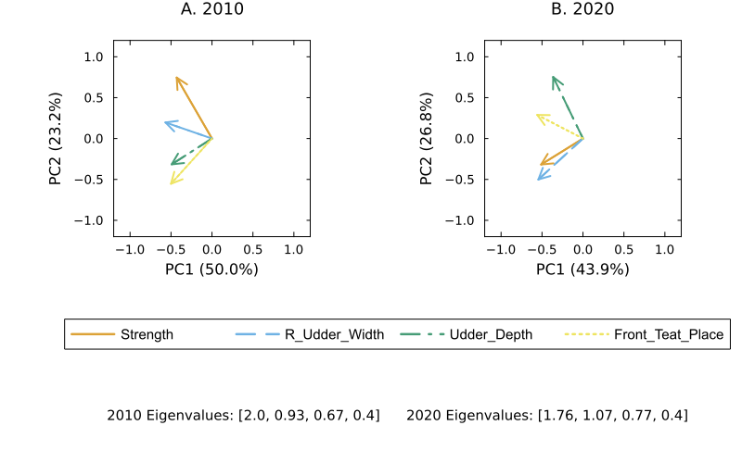Figure 12a. Principal component analysis biplots for the 4-factor regression for Rear Udder Height in 2010 and 2020.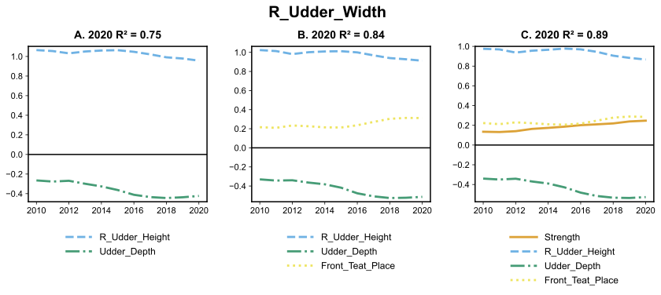Figure 13a: Coefficients of 2 (A), 3 (B) and 4(C) factor regression on Rear Udder Width over time with corresponding R² based on year 2020.
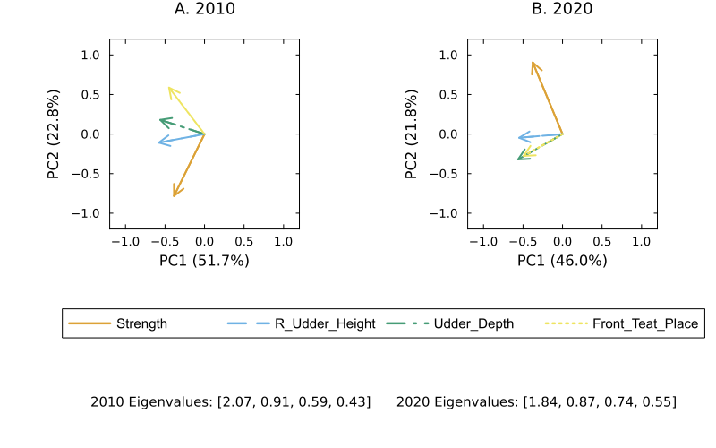Figure 14a. Principal component analysis biplots for the 4-factor regression for Rear Udder Width in 2010 and 2020.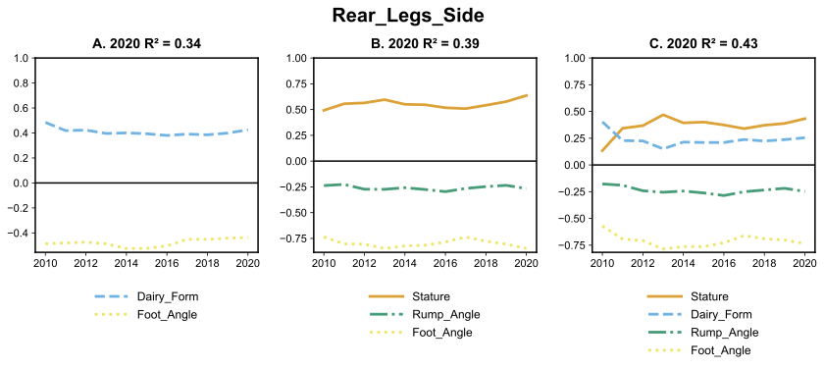Figure 15a: Coefficients of 2 (A), 3 (B) and 4(C) factor regression on Rear Legs Side View over time with corresponding R² based on year 2020.
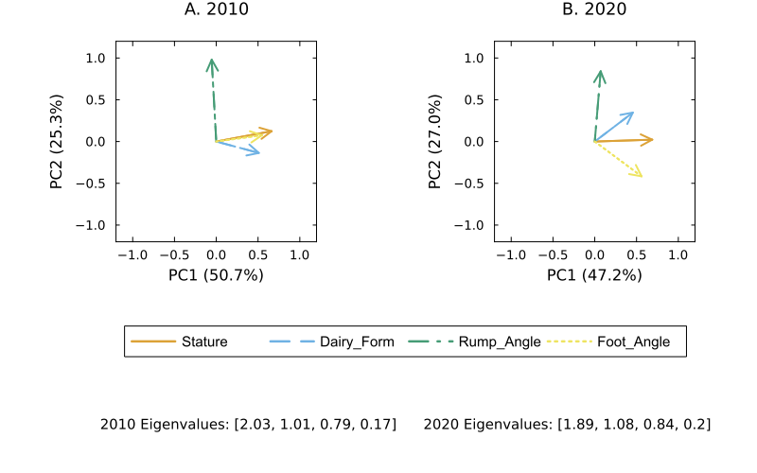Figure 16a. Principal component analysis biplots for the 4-factor regression for Rear Legs Side View in 2010 and 2020.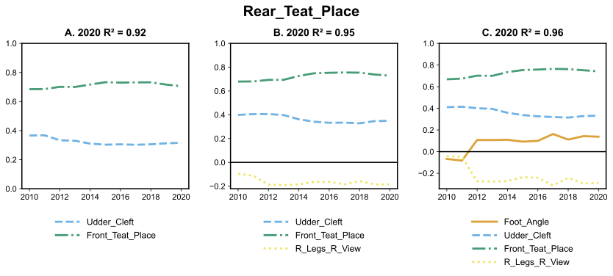Figure 17a: Coefficients of 2 (A), 3 (B) and 4(C) factor regression on Rear Teat Placement over time with corresponding R² based on year 2020.
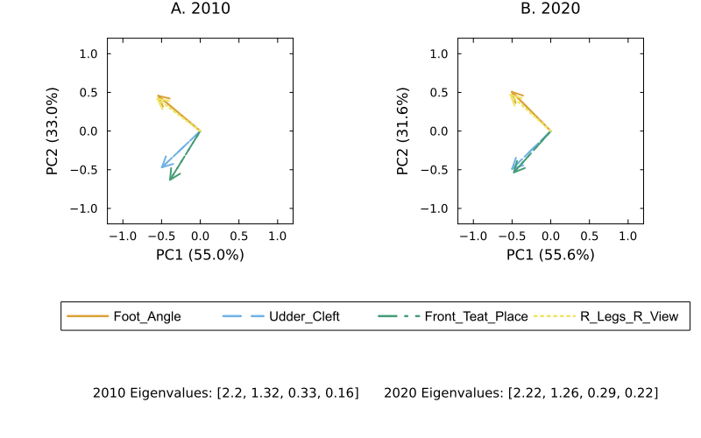Figure 18a. Principal component analysis biplots for the 4-factor regression for Rear Teat Placement in 2010 and 2020.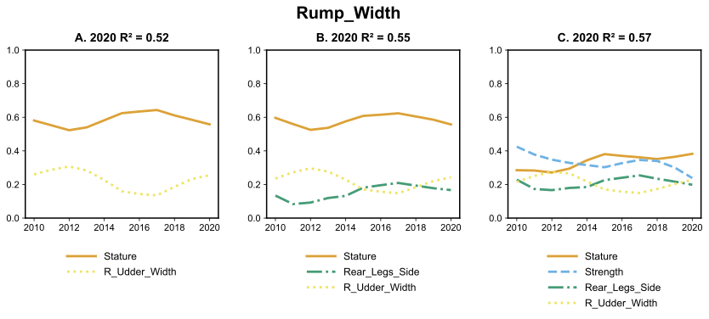Figure 19a: Coefficients of 2 (A), 3 (B) and 4(C) factor regression on Rump Width over time with corresponding R² based on year 2020.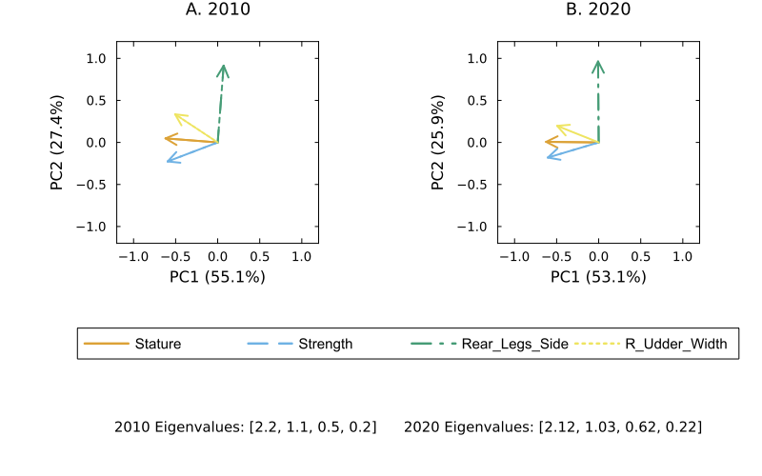Figure 20a. Principal component analysis biplots for the 4-factor regression for Rump Width in 2010 and 2020.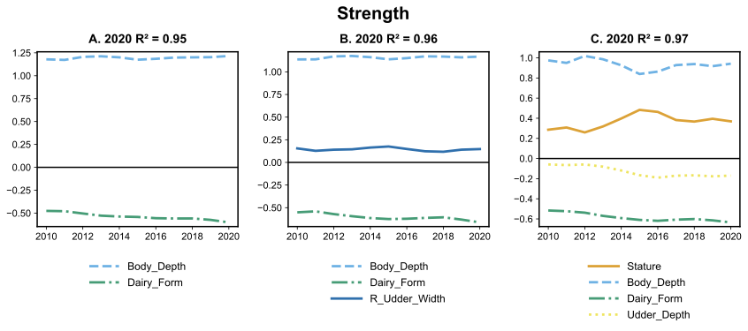Figure 21a: Coefficients of 2 (A), 3 (B) and 4(C) factor regression on Strength over time with corresponding R² based on year 2020.
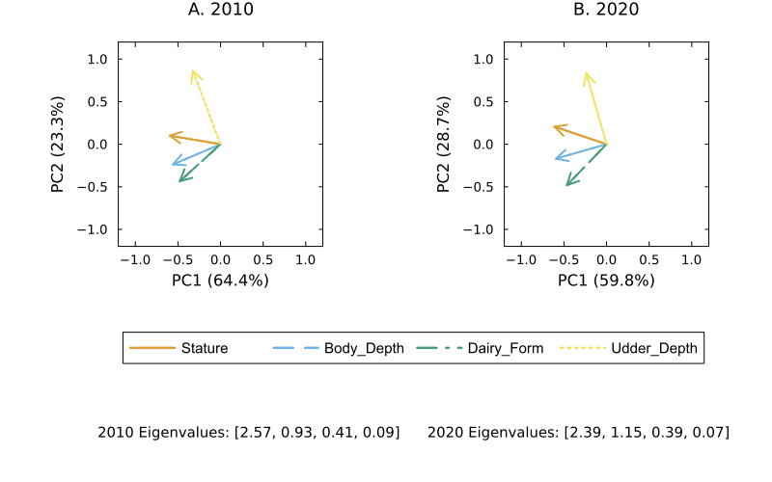Figure 22a. Principal component analysis biplots for the 4-factor regression for Strength in 2010 and 2020.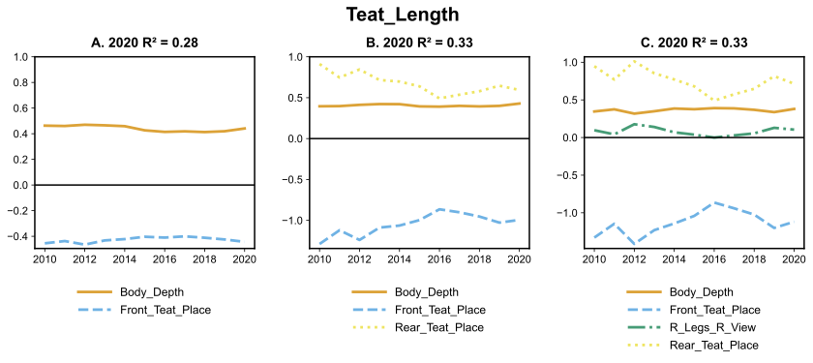Figure 23a: Coefficients of 2 (A), 3 (B) and 4(C) factor regression on Teat Length over time with corresponding R² based on year 2020.
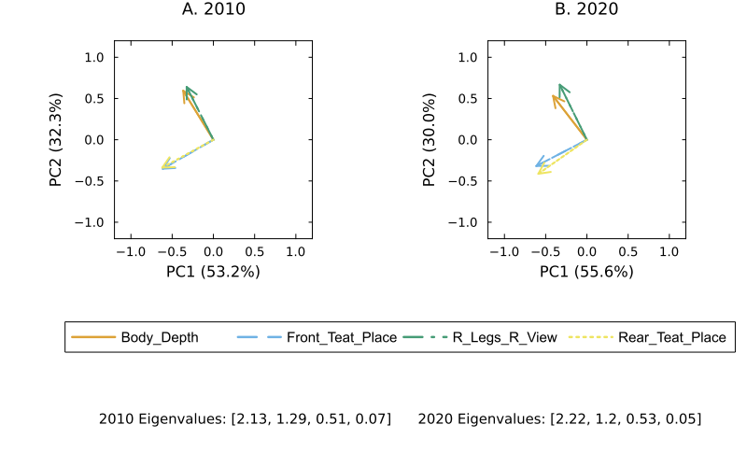
Figure 24a. Principal component analysis biplots for the 4-factor regression for Teat Length in 2010 and 2020.
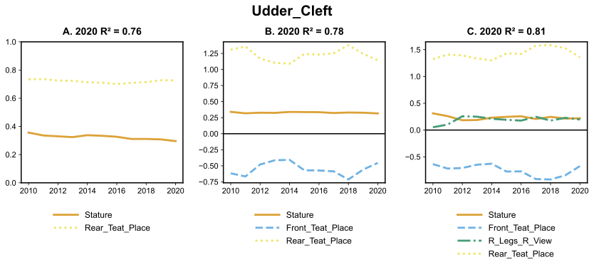Figure 25a: Coefficients of 2 (A), 3 (B) and 4(C) factor regression on Udder Cleft over time with corresponding R² based on year 2020.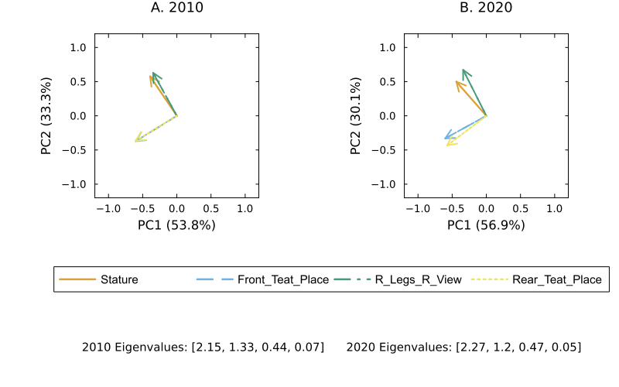
Figure 26a. Principal component analysis biplots for the 4-factor regression for Stature in 2010 and 2020.
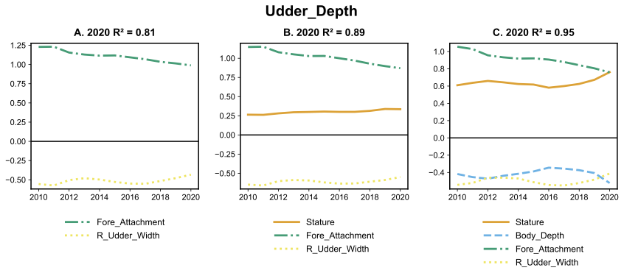Figure 27a: Coefficients of 2 (A), 3 (B) and 4(C) factor regression on Udder Depth over time with corresponding R² based on year 2020.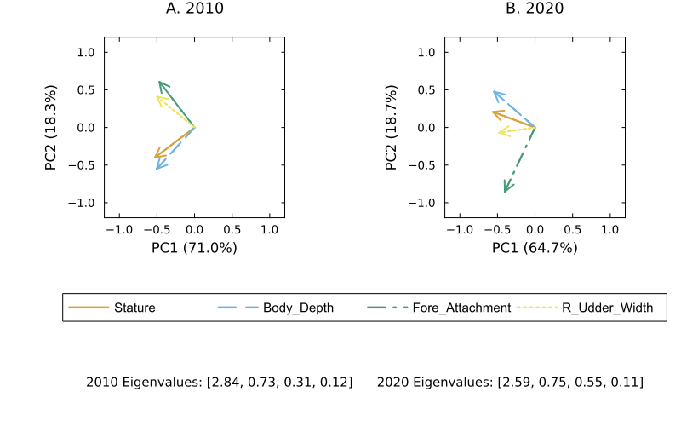Figure 28a. Principal component analysis biplots for the 4-factor regression for Udder Depth in 2010 and 2020.

